MODEL LAB
Name: Telaprolu Rohitasai
Reg no: 192425041
Course code: MLA0214
Course Name: Fundamentals of Machine Learning

Given Data set :
Experience (X): 1, 2, 3, 4
Salary (Y): 3, 5, 7, 10

QUESTION 1
Aim:
To implement linear regression to predict salary based on experience and interpret slope and intercept.
Algorithm:
- Import required libraries (NumPy, Matplotlib, sklearn).
- Define dataset (experience and salary).
- Reshape input data for model training.
- Train Linear Regression model using fit().
- Predict values and plot regression line.

CODE:
import numpy as np
import matplotlib.pyplot as plt
from sklearn.linear_model import LinearRegression

# Dataset
X = np.array([1, 2, 3, 4]).reshape(-1, 1)
y = np.array([3, 5, 7, 10])

# Model
model = LinearRegression()
model.fit(X, y)

# Prediction
y_pred = model.predict(X)

# Plot
plt.scatter(X, y)
plt.plot(X, y_pred)
plt.xlabel("Experience")
plt.ylabel("Salary")
plt.title("Linear Regression")
plt.show()

# Output
print("Slope:", model.coef_[0])
print("Intercept:", model.intercept_)
OUTPUT:
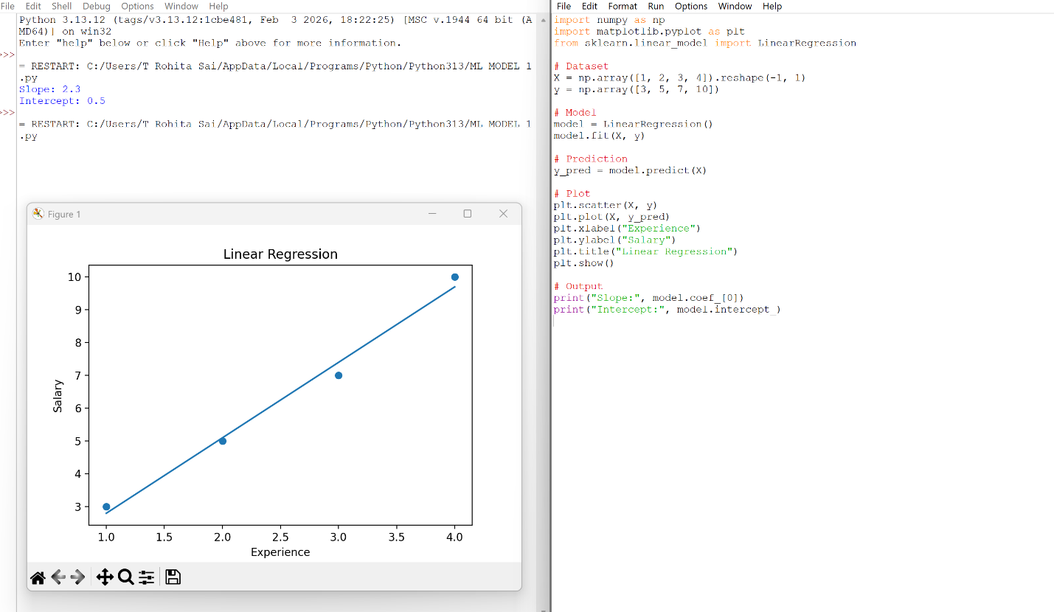

RESULT:
Linear regression successfully predicts salary. Salary increases linearly with experience.

EXPERIMENT 2
Aim:
To implement polynomial regression and compare it with linear regression.
Algorithm:
- Import libraries
- Convert input into polynomial features
- Train regression model
- Predict values
- Plot polynomial curve
Working Code:
from sklearn.preprocessing import PolynomialFeatures
from sklearn.linear_model import LinearRegression
import matplotlib.pyplot as plt
import numpy as np

X = np.array([1, 2, 3, 4]).reshape(-1, 1)
y = np.array([3, 5, 7, 10])

poly = PolynomialFeatures(degree=2)
X_poly = poly.fit_transform(X)

model = LinearRegression()
model.fit(X_poly, y)

y_pred = model.predict(X_poly)
plt.scatter(X, y)
plt.plot(X, y_pred)
plt.title("Polynomial Regression")
plt.show()
Output:
- Curve fits data better than straight line
- Slight upward curvature

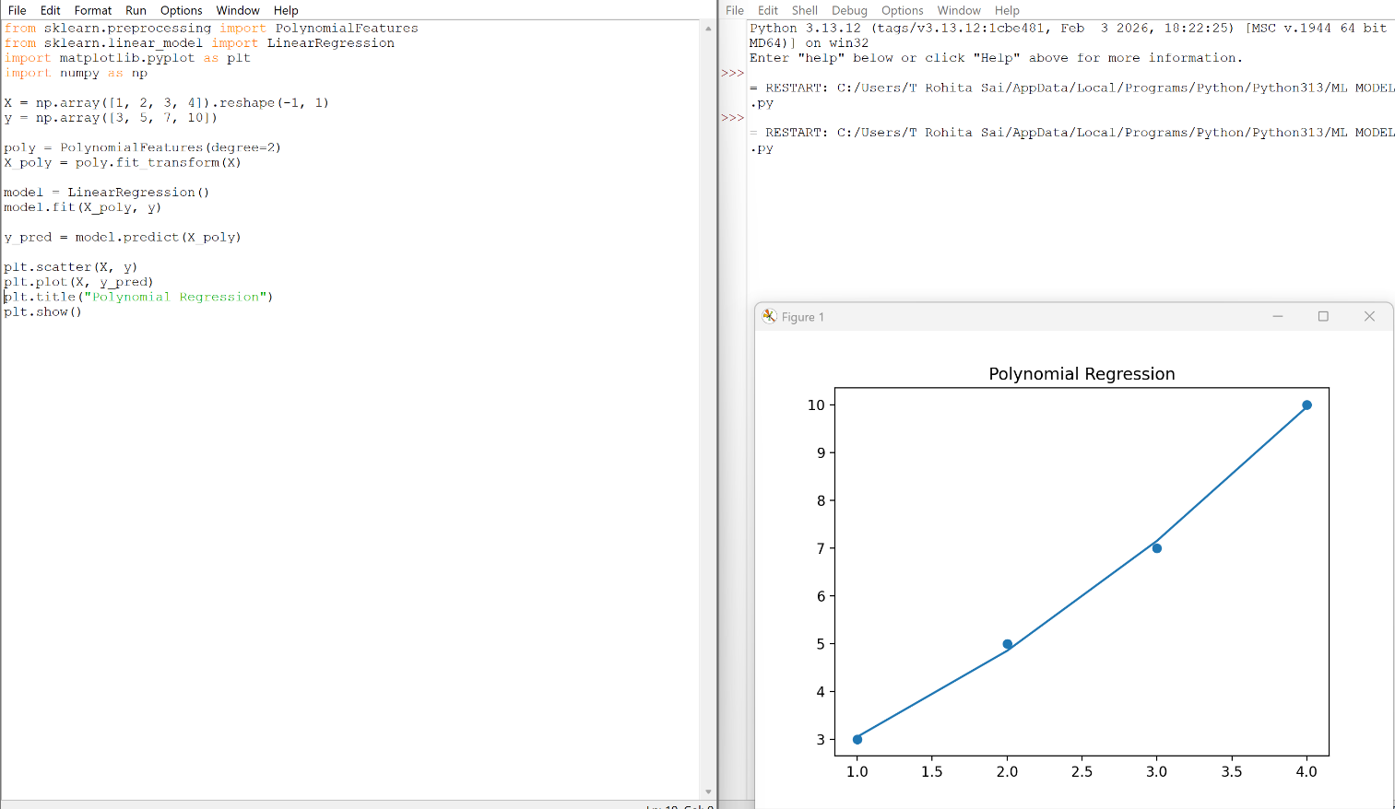

Result:
Polynomial regression provides a better fit as the data shows a non-linear trend.

EXPERIMENT 3
Aim:
To calculate and compare MSE of linear and polynomial regression models.
Algorithm:
- Train linear regression model
- Train polynomial regression model
- Predict outputs for both models
- Compute MSE for both
- Compare results
Working Code:
import numpy as np
from sklearn.linear_model import LinearRegression
from sklearn.preprocessing import PolynomialFeatures
from sklearn.metrics import mean_squared_error

# Define dataset (IMPORTANT - this was missing)
X = np.array([1, 2, 3, 4]).reshape(-1, 1)
y = np.array([3, 5, 7, 10])

# Linear Regression
model1 = LinearRegression()
model1.fit(X, y)
y1 = model1.predict(X)

# Polynomial Regression
poly = PolynomialFeatures(degree=2)
X_poly = poly.fit_transform(X)

model2 = LinearRegression()
model2.fit(X_poly, y)
y2 = model2.predict(X_poly)

# MSE Calculation
mse_linear = mean_squared_error(y, y1)
mse_poly = mean_squared_error(y, y2)

print("Linear MSE:", mse_linear)
print("Polynomial MSE:", mse_poly)
OUTPUT:
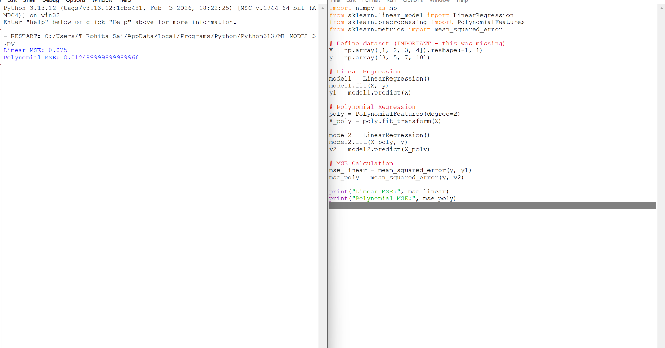

Result
Polynomial regression has lower error, indicating better performance on training data.
EXPERIMENT 4
Aim:
To demonstrate overfitting using higher-degree polynomial regression.
Algorithm:
- Convert data into higher-degree polynomial features
- Train regression model
- Predict outputs
- Plot graph
- Observe curve behavior
Working Code:
from sklearn.preprocessing import PolynomialFeatures
from sklearn.linear_model import LinearRegression
import matplotlib.pyplot as plt
import numpy as np

X = np.array([1, 2, 3, 4]).reshape(-1, 1)
y = np.array([3, 5, 7, 10])

poly = PolynomialFeatures(degree=4)
X_poly = poly.fit_transform(X)

model = LinearRegression()
model.fit(X_poly, y)

y_pred = model.predict(X_poly)

plt.scatter(X, y)
plt.plot(X, y_pred)
plt.title("Overfitting Example")
plt.show()
Output:
- Curve passes exactly through all points
- Graph appears overly complex
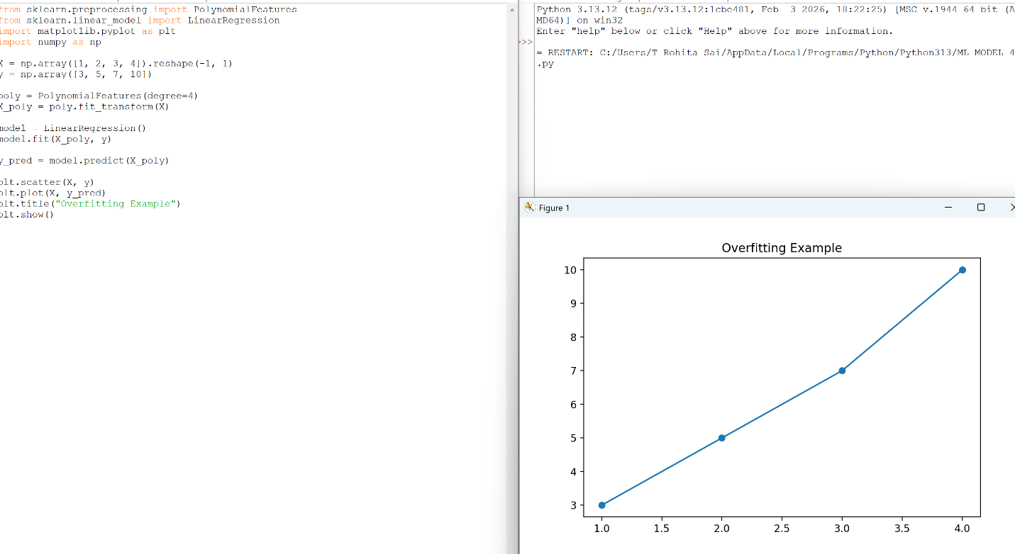

Result:
Higher-degree polynomial leads to overfitting, making the model less reliable for new data.

